**APPLICATION EXPLORATION**

***The Mystery Curve***

***A Signal Processing Point of View***

*Harshraj Chaudhari, Swadhin Dash and Harsh Shah*

**Overview:**

* Firstly we start with the introduction to Mystery Curve, look at some examples and understand there relevance.
* Next we look at the Fourier Series approach to these beautiful curves, and understand its shortcomings.
* Apart from this we will look at an alternate approach to generation of Mystery Curves.
* Finally we will extrapolate this to 3-D.
* ***What are “Mystery Curves”?***
* Mystery Curves are described by Frank Farris in his book **Creating Symmetry.** They are a kind of circular harmonograph, each created by summing three circular components, and are used a lot in creative programming.



Above is an animation that shows a mystery curve as a summation of 3 circles

* Example : Consider three rotating Circles $μ\left(t\right):$

$μ\left(t\right)=\{\left(sinsin t +\frac{sinsin 6t }{2}+\frac{coscos 14t }{3},coscos t +\frac{coscos 6t }{2}+\frac{sinsin 14t }{3}\right)$

We can plot this parametric curve on Desmos to get a 5-Fold symmetric Mystery Curve.



* The beautiful N-fold symmetry curve can be extended to 3-D cases by similar definition in two dimensions. Today, 3-D printing is popular, and affordable, and modern sculptures or artwork created by the 3-D mystery curve might decorate our living rooms in the near future.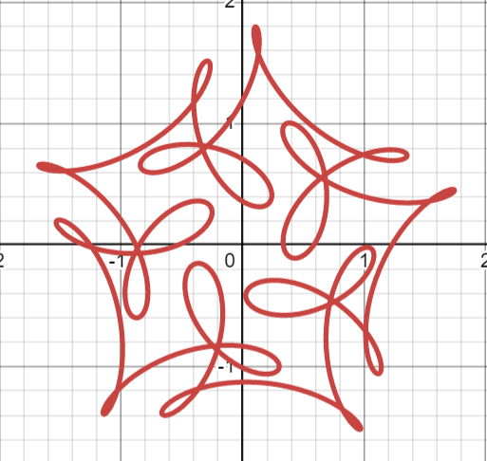
* ***Fourier Series Approach:***
* A N-Fold symmetric curve must follow :
$ⅇ^{ⅈ\frac{2πk}{N}}⋅c\left(t\right)=c\left(t+\frac{2π}{N}\right)$

* From here by using Fourier series it can be proved that
$C\left(t\right)=ⅇ^{ⅈkt}\left(\sum_{n^{'}=-∞}^{∞}{}C_{n'}⁡ⅇ^{Nn^{'}t}\right)$

* For our example $c\left(t\right)=ⅇ^{it}(1+\frac{1}{2}ⅇ^{i5t}+\frac{1}{3}ⅇ^{-i15t})$ with N=5, k = 1 ,C0=1, C1=1/2 and C-3=i/3.
* To generate a good pattern we require a considerate amount of trial and error. To design a good pattern easily, one might want to draw a curve locally and then rotate it N times. This can be done by considering polar coordinate system instead of Cartesian coordinate system, as we will discuss in the next section.
* ***Alternate Method: Polar Form Method***
* Expressing the curve as polar form and solving the symmetry equation we get :

$r\left(t+\frac{2π}{N}\right)=r\left(t\right)$ and $θ\left(t+\frac{2π}{N}\right)=θ\left(t\right)+\frac{2π}{N}k$

* This implies that $r\left(t\right)$ is a periodic function and $θ\left(t\right)$ is a linear combination a periodic function ( w.p $\frac{2π}{N}$) and a linear function.
* Examples: take $r\left(t\right)=\frac{1}{1.3+sinsin 7t }$ and $θ\left(t\right)=t+sinsin 7t$, we get:

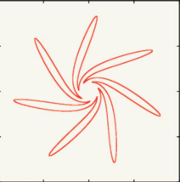

Replacing $r\left(t\right) by$ $r\left(t\right)=\frac{2coscos \left(7t\right) -1}{1.1+sinsin 7t }$ to get:

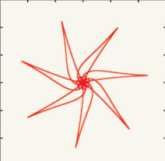

Replacing $r\left(t\right) by$ $r\left(t\right)=\frac{cos⁡(7t)+sin⁡(14t)-1}{2+sinsin 7t }$ to get:

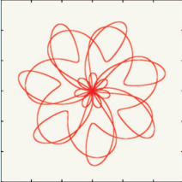

* The drawback here is that here we get high harmonic/ frequency terms and the curve is not smooth. This can be tackled by filtering out high frequency bin from its Fourier spectrum.
* ***Mystery Curves in 3-D***
* Like the case in 2-D, the mystery curve in 3-D can be defined by time shift and rotation operation.
* By the Euler rotation theorem, any combination of three dimension rotations is equivalent to a single 2-D rotation [ about an axis( taken as z-axis).
* Therefore, the $x\left(t\right)$ and $y\left(t\right)$ must satisfy the same constraints as the 2-D case, and $z\left(t\right)$ is a periodic signal with period $\frac{2π}{N} .$
* Example : Let the 2-D curve be

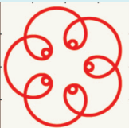

Setting $z\left(t\right)=1+cos5t$ we get

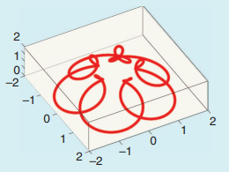

**References**

* [**The Mystery Curve: A Signal Processing Point of View [Lecture Notes]**](https://ieeexplore.ieee.org/document/8103130/)
* [Soo-Chang Pei](https://ieeexplore.ieee.org/author/37271112500);[Kuo-Wei Chang](https://ieeexplore.ieee.org/author/37634193600)
* [IEEE Signal Processing Magazine](https://ieeexplore.ieee.org/xpl/RecentIssue.jsp?punumber=79)
* Year: 2017 | Volume: 34, [Issue: 6](https://ieeexplore.ieee.org/xpl/tocresult.jsp?isnumber=8103076) | Magazine Article | Publisher: IEEE
* Cited by: [Papers (7)](https://ieeexplore.ieee.org/document/8103130/citations?tabFilter=papers#citations)
* [Mathematical Art and Creative Coding - Mystery curves (georgemsavva.github.io)](https://georgemsavva.github.io/creativecoding/posts/mystery/#:~:text=%E2%80%98Mystery%20curves%E2%80%99%20are%20described%20by%20Frank%20Farris%20in,two%20pieces%20are%20both%20based%20on%20mystery%20curves%3A)

**SOME BEAUTIFUL MYSTERY CURVES**

To finish off we would present some beautiful Mystery Curve animations. The script for the are written in R using the gifski package to give gif.. We came across these while researching foe this topics.



